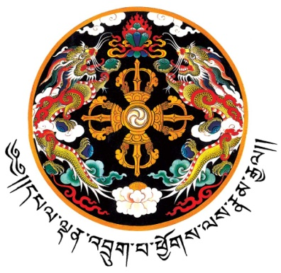

ROYAL BHUTANESE EMBASSY
BRUSSELS

RBE/BRU/MEDIA/2016/ 2nd June 2016

PRESS RELEASE

Subject: Bhutan’s Ambassador presented the Letters of Credence to the King of Sweden
---------------------------------------------------------------------------------------------------------------

On 2nd June 2016, Ambassador Pema Choden presented her Letters of Credence to His Majesty Carl XVI Gustaf, King of Sweden, accrediting her as Ambassador Extraordinary and Plenipotentiary of the Kingdom of Bhutan to the Kingdom of Sweden at the Royal Palace in Stockholm.

His Majesty King Carl XVI Gustaf welcomed Ambassador Pema Choden to Sweden and wished her success in her responsibilities in promoting bilateral relationship between the two Kingdoms. Ambassador Pema Choden conveyed the warm greetings from His Majesty the King and Her Majesty the Gyaltsuen to the King and Queen of Sweden. She thanked the King for his wishes and conveyed the desire of the Royal Government and her personal commitment to further strengthen the friendly relations between the two Kingdoms. She stated that the Royal Government of Bhutan was greatly encouraged by the King’s personal interest in promoting bilateral relations between Bhutan and Sweden and looked forward to receiving him in Bhutan on a State Visit from 8 to 11 June 2016.

His Majesty the King recalled his first visit to Bhutan in October 1993 and mentioned that he looked forward to his second visit in June.

While in Stockholm, Ambassador Pema Choden met with senior officials of the Swedish Foreign Ministry and discussed ways to further deepen bilateral relationship between the two countries. She also met with the members of the Sweden–Bhutan Friendship Society.

Ambassador Pema Choden is Bhutan’s resident Ambassador to Belgium and the European Union with concurrent accreditation to Denmark, Finland, the Netherlands, Spain and Sweden.

Embassy of the Kingdom of Bhutan
Brussels
2 June 2016

Avenue Jules Cesar 70, 1150 Brussels, Belgium Tel No. (0032) 02 761.95.70 Fax No. (0032) 02 761.95.77
E-mail: infobhutan@bhutanembassy.be

